ANALYSTLAB AFRICA
WEEK 5 • BUSINESS ANALYTICS CASE STUDY
Telco Customer Churn
Turning customer data into retention decisions
7,043  Customers | 1,869  Churned | 5,174  Retained | 26.5%  Overall churn

Prepared for AnalystLab Africa Data Analytics Internship -Batch C

Executive Summary
This case study analyzes the Telco Customer Churn dataset to understand why customers leave, identify the customer groups most exposed to churn, and translate those patterns into practical retention actions. The analysis shows that churn is not evenly distributed: contract type, tenure, monthly charges, payment method, internet service and support-related services show clear differences between customers who leave and those who stay.
Headline finding: Month-to-month customers have a 42.7% churn rate, compared with 2.8% for two-year customers.

1. Business Problem Statement
The telecom company is losing customers and needs to understand the factors associated with that loss. The business questions for this analysis are: Why are customers leaving? Which customer segments are most likely to churn? Which factors deserve the strongest retention attention? And what actions can management take based on the evidence?

2. Dataset Description
The Telco Customer Churn dataset contains 7,043 customer records and 21 variables. It includes customer demographics, services subscribed to, contract and payment information, monthly and total charges, and the Churn outcome.
Area | Examples
Customer profile | Gender, Senior Citizen, Partner, Dependents
Services | Internet Service, Tech Support, Online Security, Streaming
Account | Tenure, Contract, Paperless Billing, Payment Method
Financial | Monthly Charges, Total Charges
Outcome | Churn

3. Data Analysis Process
- Imported and profiled the dataset, checking dimensions, fields, unique values and data types.
- Assessed data quality, including missing values in TotalCharges.
- Converted TotalCharges to numeric so it could be used correctly in analysis.
- Explored customer and account variables using summary statistics and segmented comparisons.
- Calculated churn rates across key customer groups and compared retained versus churned customers.
- Interpreted the strongest patterns as business insights and translated them into targeted recommendations.

4. Key Findings
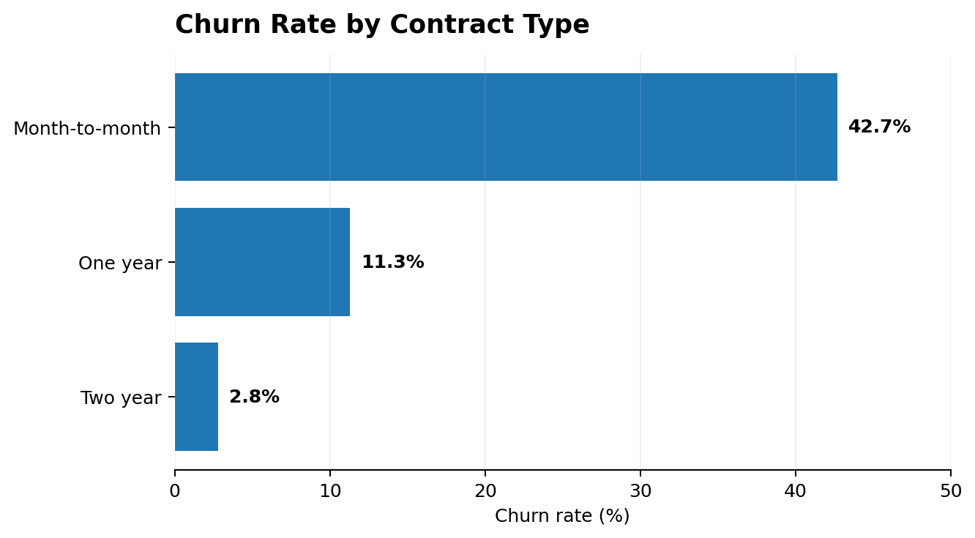
Contract type is the clearest segmentation signal: customers with less commitment churn much more often.
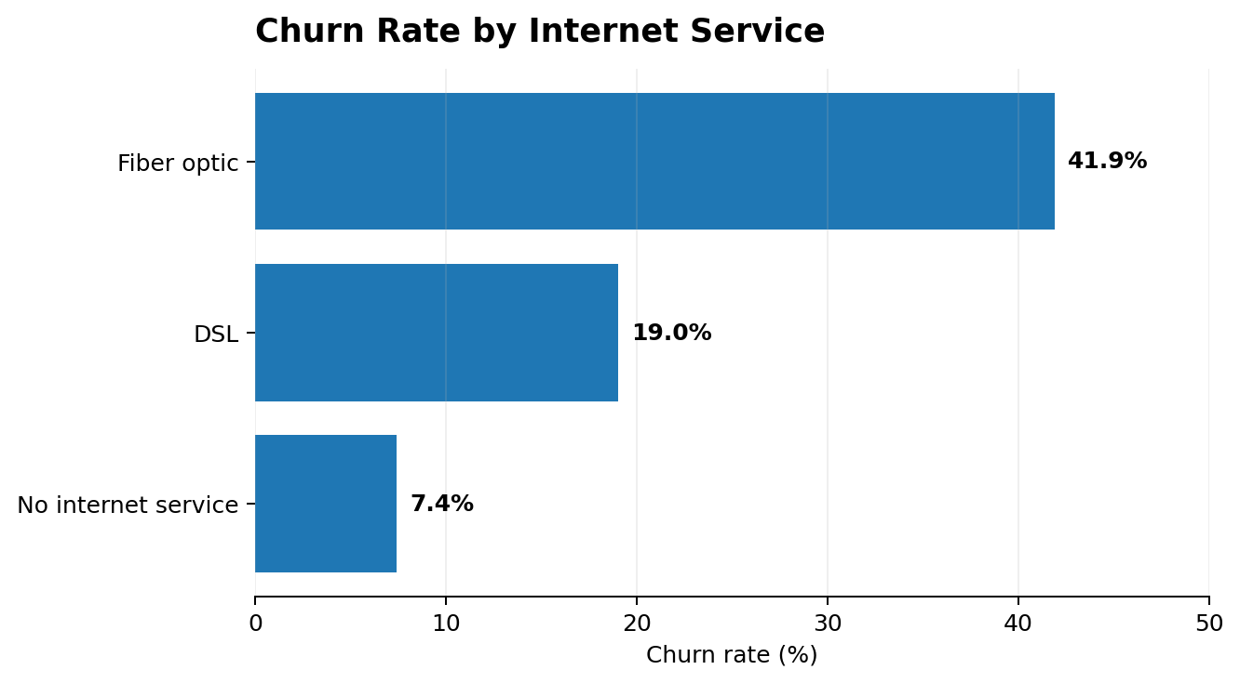

5. Customer Segments Requiring Attention
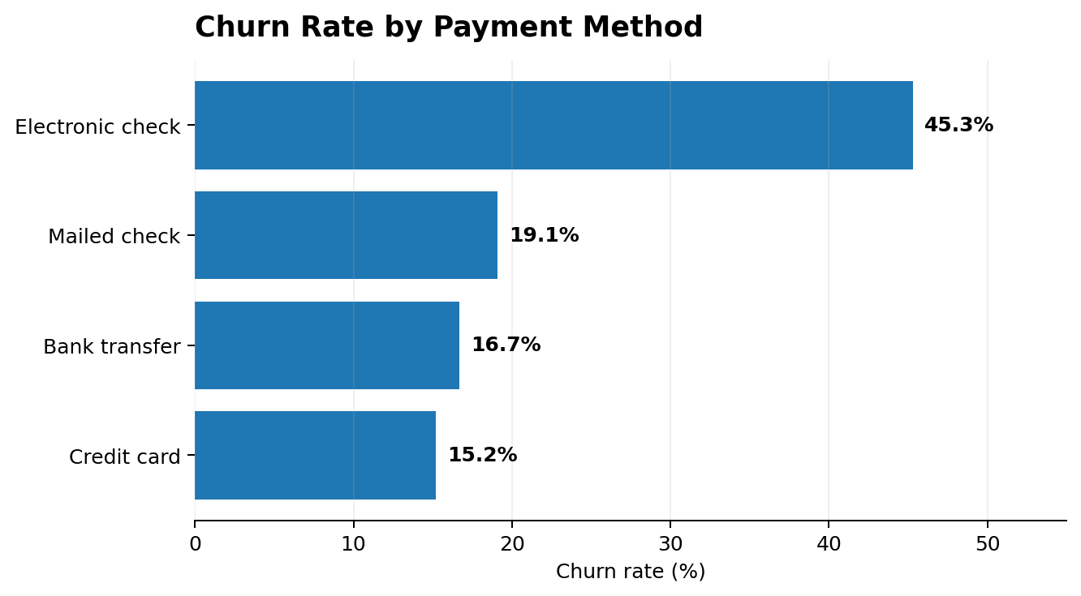
Metric | Customers who stayed | Customers who churned
Average tenure | 37.6 months | 18.0 months
Average monthly charge | 61.27 | 74.44
Tenure is especially important: churned customers average about 18 months with the company, versus about 38 months among customers who stay. Churned customers also carry a higher average monthly charge. These patterns point to an important retention window early in the customer relationship and a need to make the value of higher-priced plans clear.

6. Business Insights
Month-to-month customers are the highest-risk group. Their 42.7% churn rate is far above the 11.3% for one-year and 2.8% for two-year contracts.
Newer customers are more vulnerable. The average tenure gap between churned and retained customers suggests that the early customer experience matters.
Higher monthly charges coincide with higher churn. Churned customers average 74.44 per month versus 61.27 among retained customers.
Electronic-check customers need attention. This segment records the highest churn rate among the payment methods analyzed.
Support services show a strong retention association. Customers with technical support and online security have much lower churn rates than customers without them.

7. Business Risks and Opportunities
Risks | Opportunities
• High churn among month-to-month customers  • Loss of newer customers  • Potential dissatisfaction among high-charge/fiber customers  • Retention resources may be spread too broadly | • Contract conversion incentives  • Early-stage customer retention program  • Fiber experience review  • Targeted retention campaigns  • Value-based offers

8. Actionable Recommendations
1. Incentivize longer-term contracts
Offer discounts, benefits or bonus services to month-to-month customers who move to one-year or two-year contracts.
2. Build an early-stage retention program
Use onboarding check-ins and targeted engagement during the first year to detect dissatisfaction before customers leave.
3. Investigate the fiber optic experience
Review pricing, reliability, installation and support before assuming the service itself is the problem.
4. Review value for high-charge customers
Use plan reviews and loyalty offers to make the value proposition clearer for customers paying higher monthly charges.
5. Prioritize high-risk segments
Combine contract, tenure, charges, payment and service indicators to focus retention resources on customers most likely to churn.

9. Conclusion
The analysis shows that customer churn is concentrated in identifiable customer segments rather than occurring randomly. Contract type is the strongest visible segmentation signal, while shorter tenure, higher monthly charges, electronic-check payment and limited support services also stand out. The business should therefore move from a broad retention approach to targeted interventions that address customers' commitment level, early experience and perceived value.

Analytical Note
The findings describe associations in the dataset; they do not by themselves prove that a factor causes churn. For example, the high churn rate among fiber-optic customers is a signal for investigation, not proof that fiber service causes customers to leave.

